//list of all the reports by Anirudh sir

Login Page for ASHA: The application is made exclusively for ASHA workers. To prevent the non-authorized users from using the application, ASHA has to login with the username and password given to her by the medical supervisor working at the Primary Health Care centre. On click of the login button, the asynchronous process fetches the personal information of ASHA like her name, contact number, village id, Aadhaar card number (ID for the unique identification of a person) in the background, and inserts it into the SQLite database for the offline use.

Registration Page: Online Registration of the pregnant woman by ASHA is the first step of the process. The registration fields include edit texts viz. personal details like name, middle name, surname, date of birth, date of last menstrual period, contact number, Aadhaar card number, and checkboxes viz. ANC visit1, ANC vist2, ANC visit3, ANC visit4. On the successful submission of the form, the patient gets registered in ASHA’s table in the MongoDB Database on the server as well as in the SQLite database which is local to the android device. This enables the application to work offline since internet connection is not a luxury in most of the villages in India. To synchronize the SQLite and MongoDB database, the information gets inserted in SQLite database only if the insertion in MongoDB database is successful. On click of the submit button, the SQLite database is checked from top to bottom and all the dual entries if made mistakenly, are deleted.

With reference to the date of last menstrual period, the due date (Estimated Date of delivery) will be calculated and shall be fed to both the databases (MongoDB and SQLite) automatically.

Immunization: Doses of OPV-1, OPV-2, OPV-3 and measles are considered as the mandatory vaccinations that are to be given within one year after birth.

Registration of the infants: The pregnant women who are registered by ASHA already and who have now surpassed the due date will appear in a list in this activity. This will make it easier for ASHA to identify new-borns and get them registered for the immunization. The new-borns of the corresponding women are registered in the local as well as the server database. The registration fields include name of the new-born and its birthdate, the rest of the fields like mother’s name, father’s name, unique identification number, address and contact number will be copied same as that of its mother. Provision is also made to register the new-borns whose mothers were not registered before. In this case, a separate registration form will be present, including all the fields as mentioned above. The submission of the form will add a new entry to the local database and update the fields for new-born in the mother-child row in the server database.

//list of all the reports that we are generating

Login for the health care centre: Every Health Care centre linked to this system is authenticated with a username and password given by the system administrator

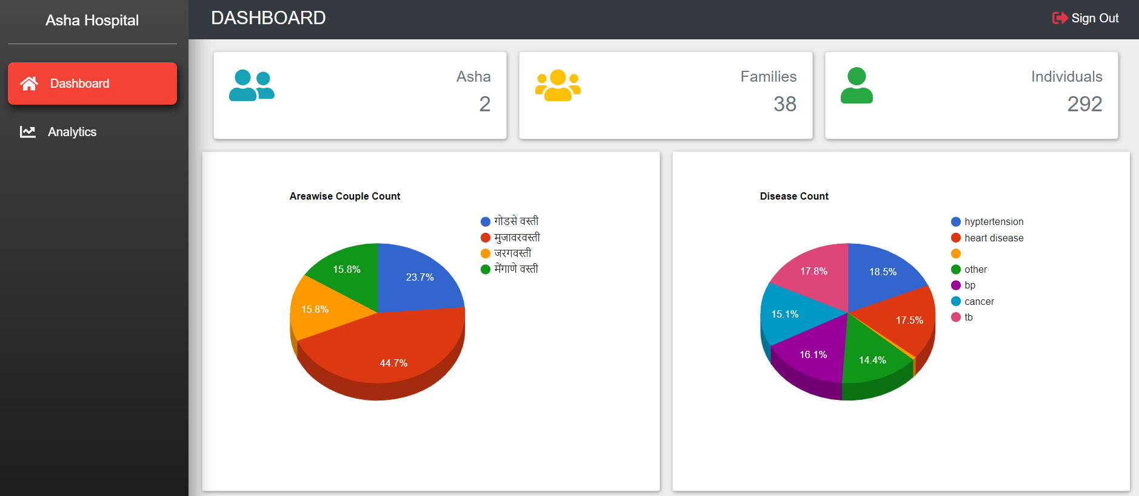

Analysis for the Admin

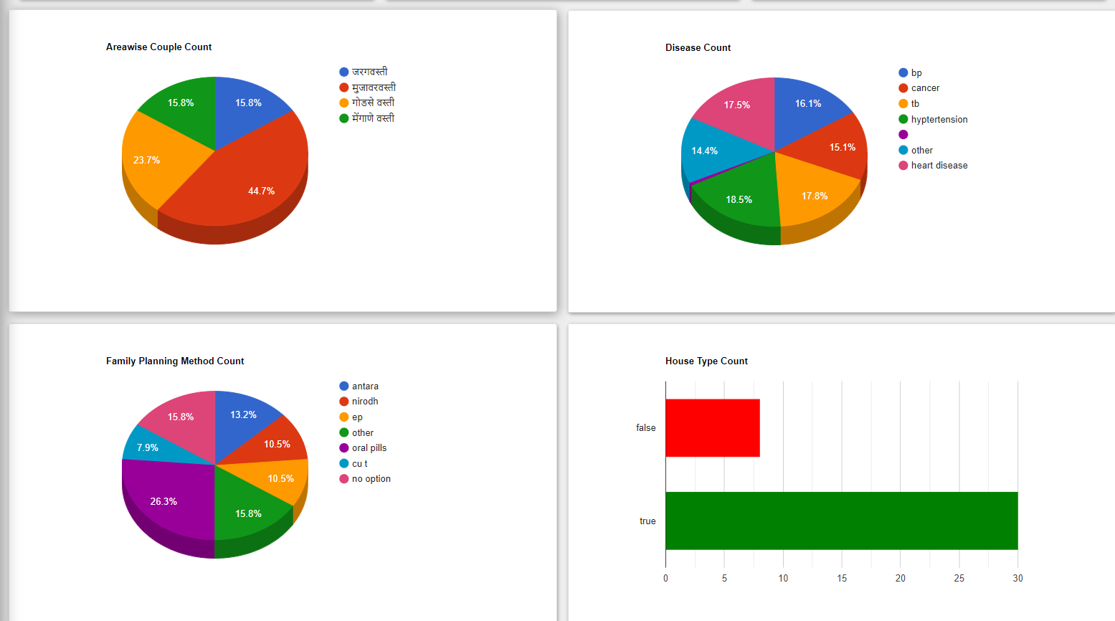

Statistical analysis of the area\

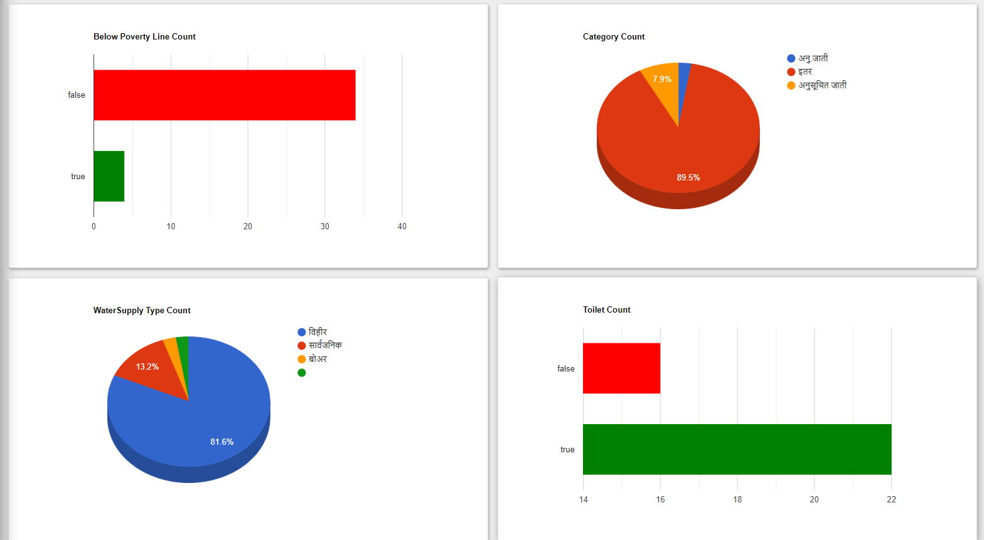

More Graphs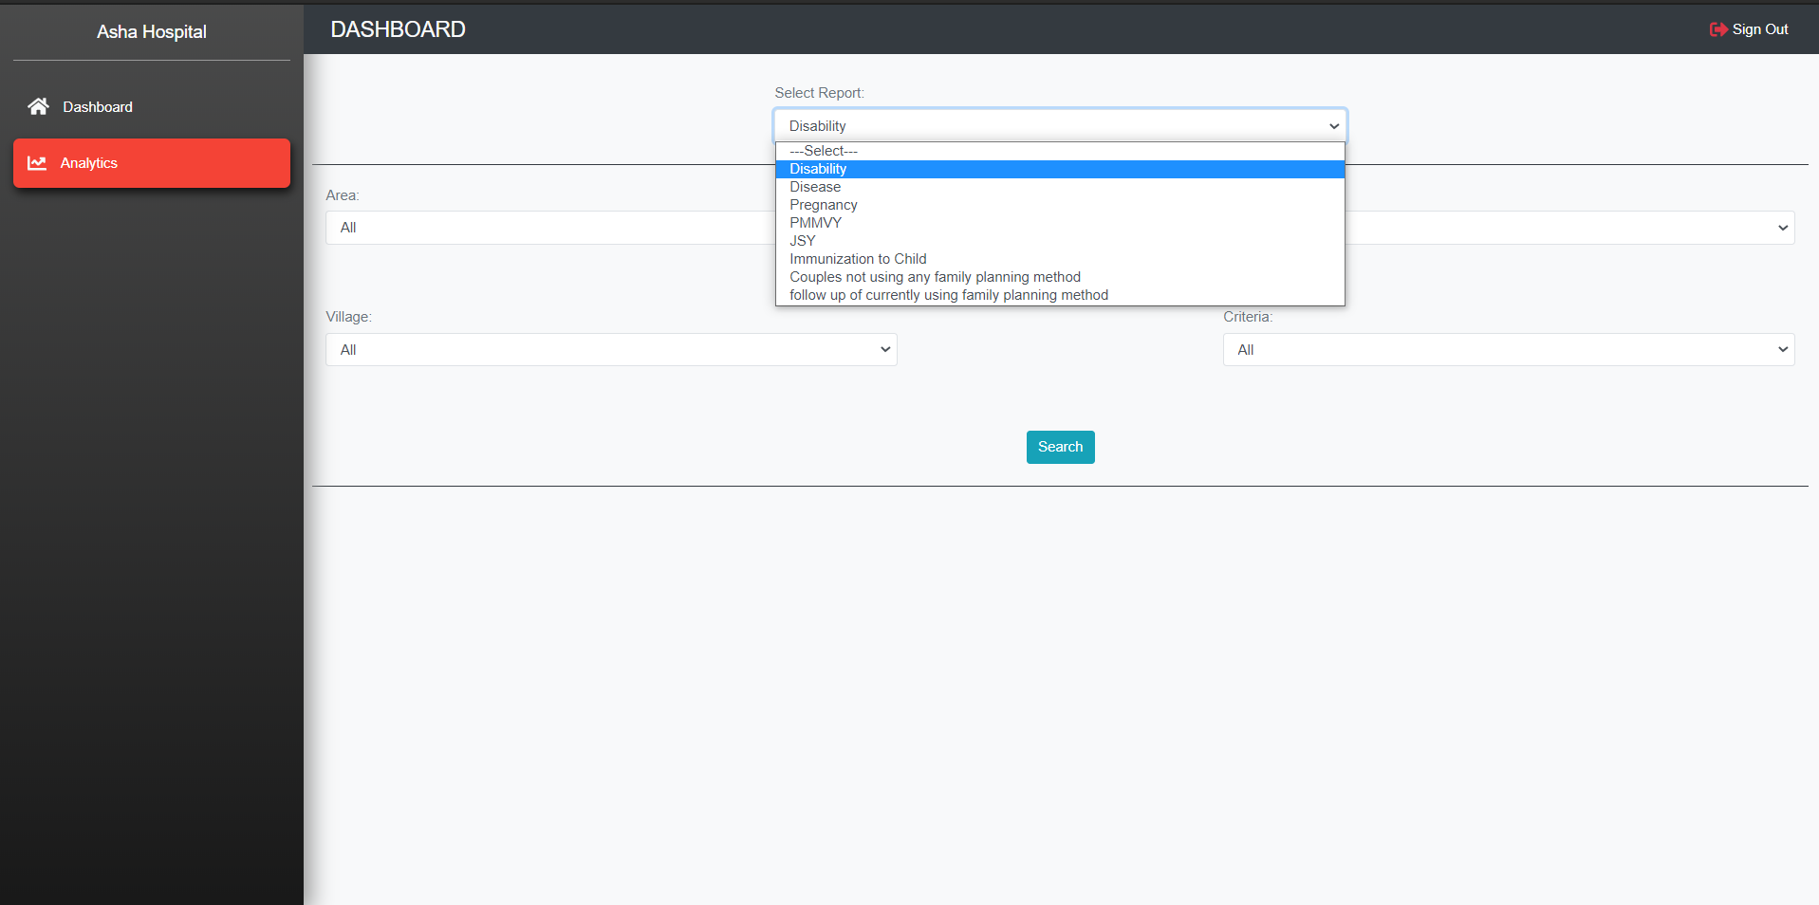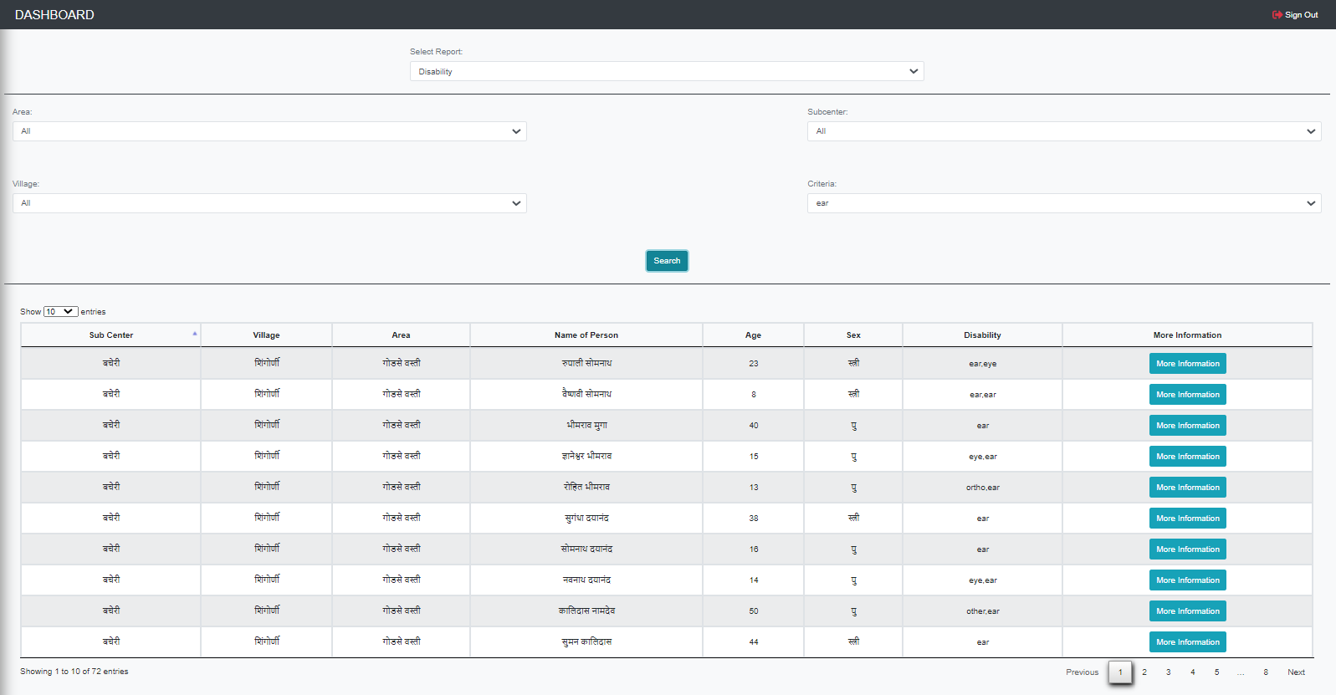Diseases

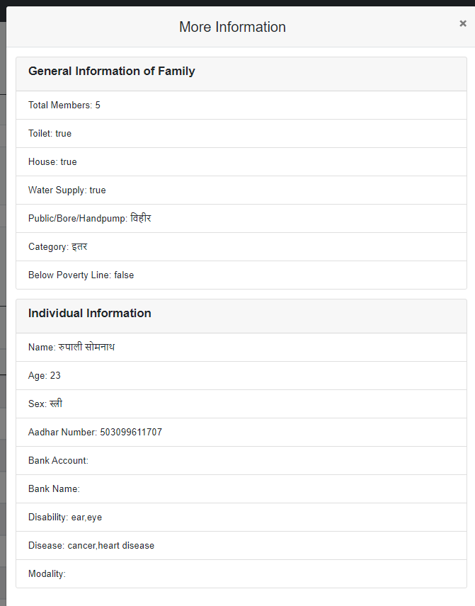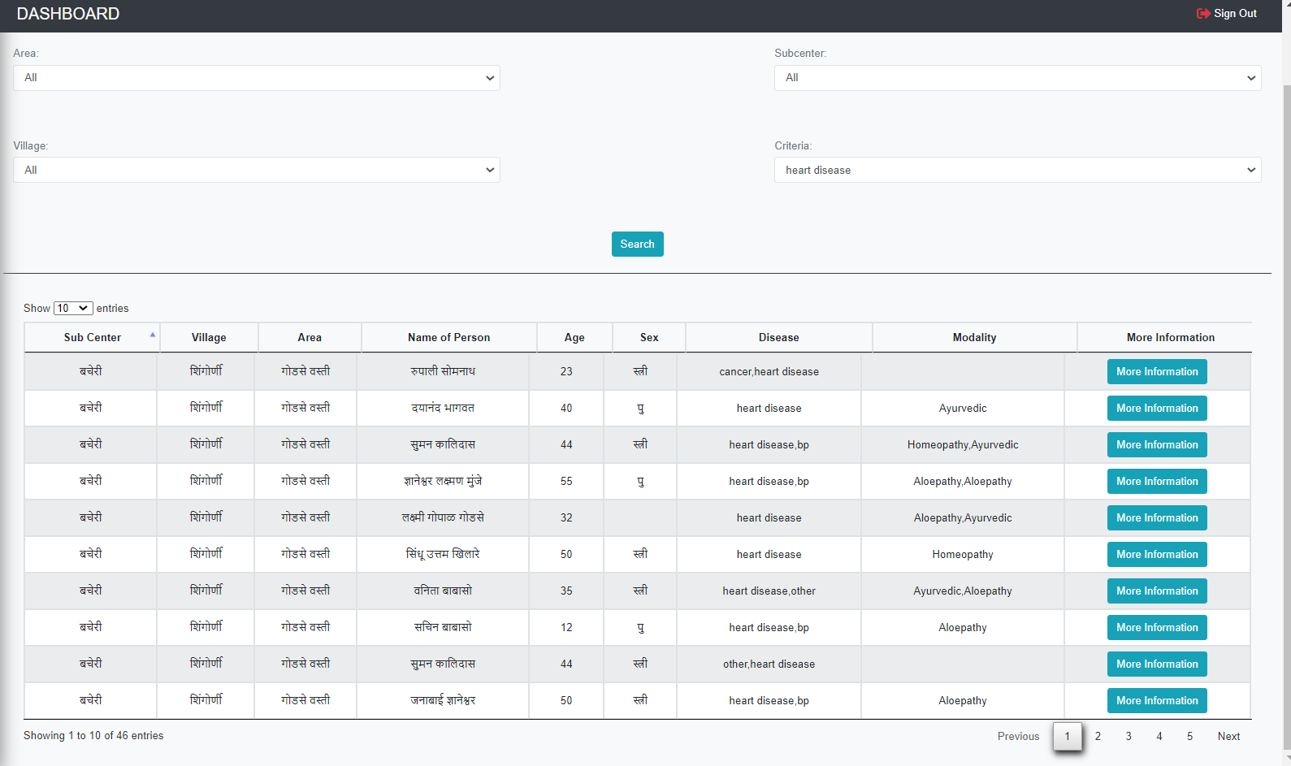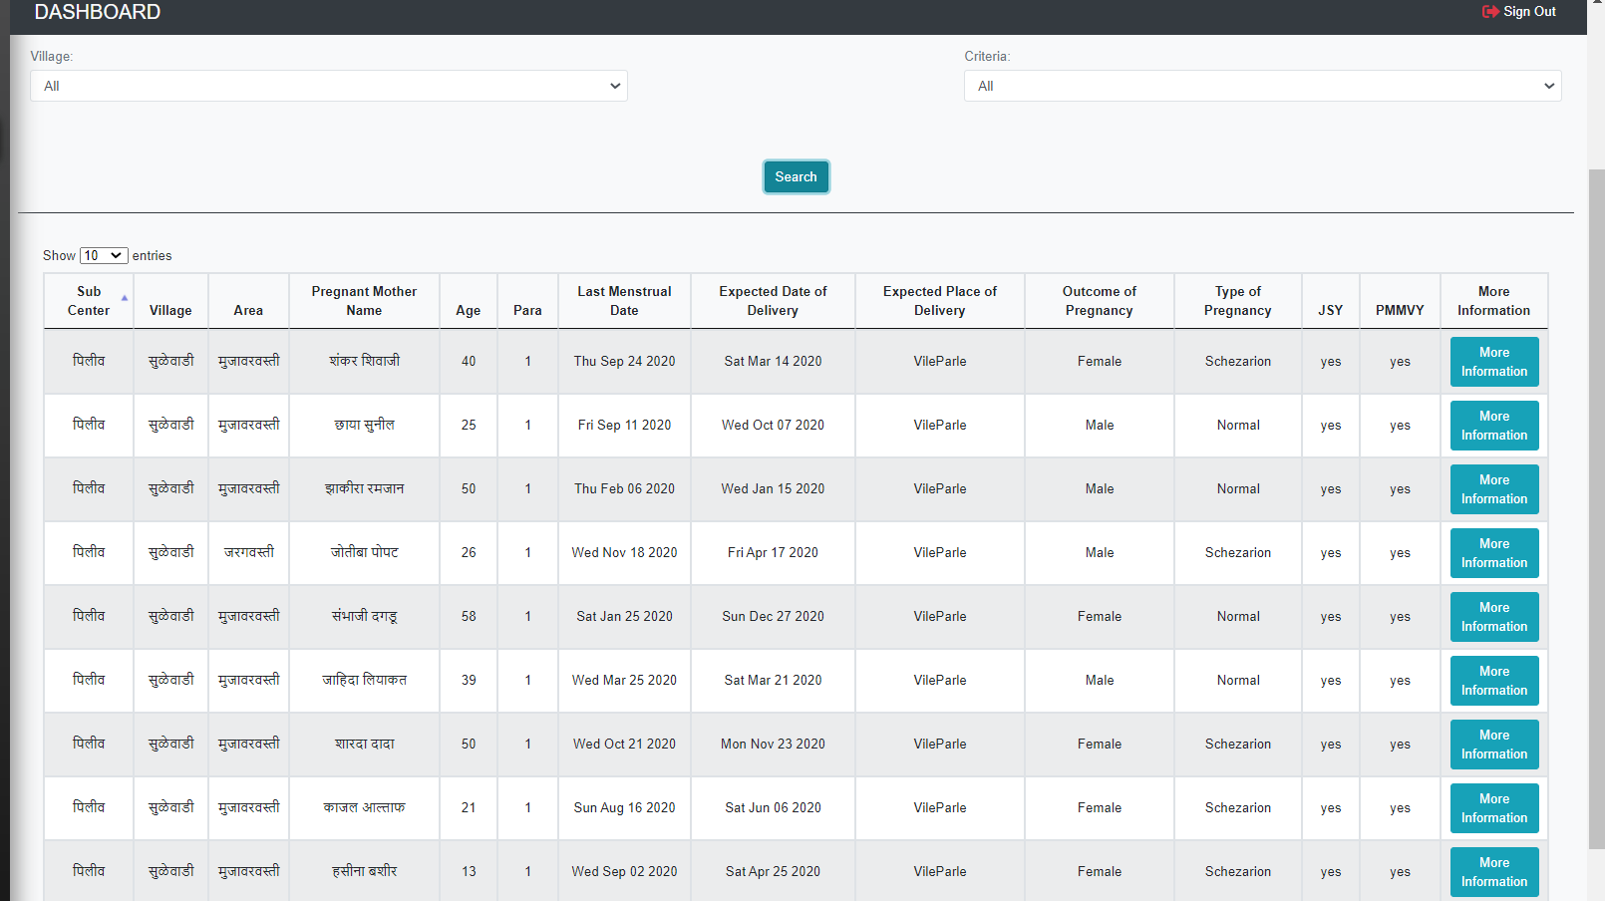

List of pregnant women

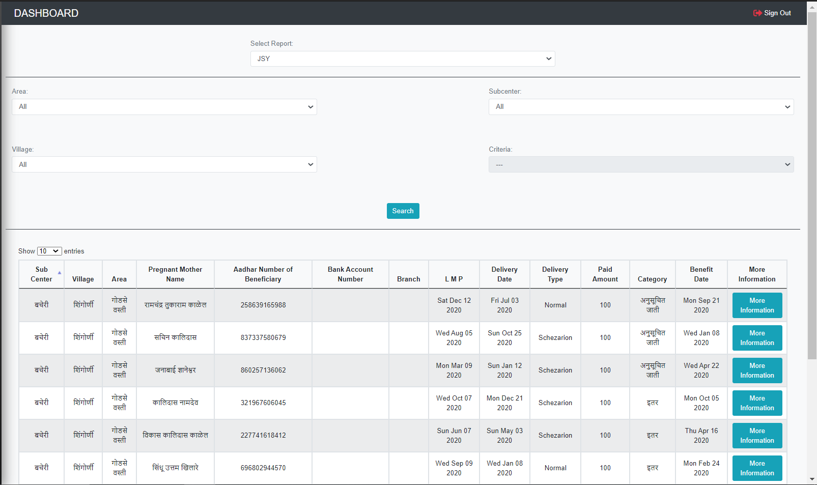

JSY details of pregnant women

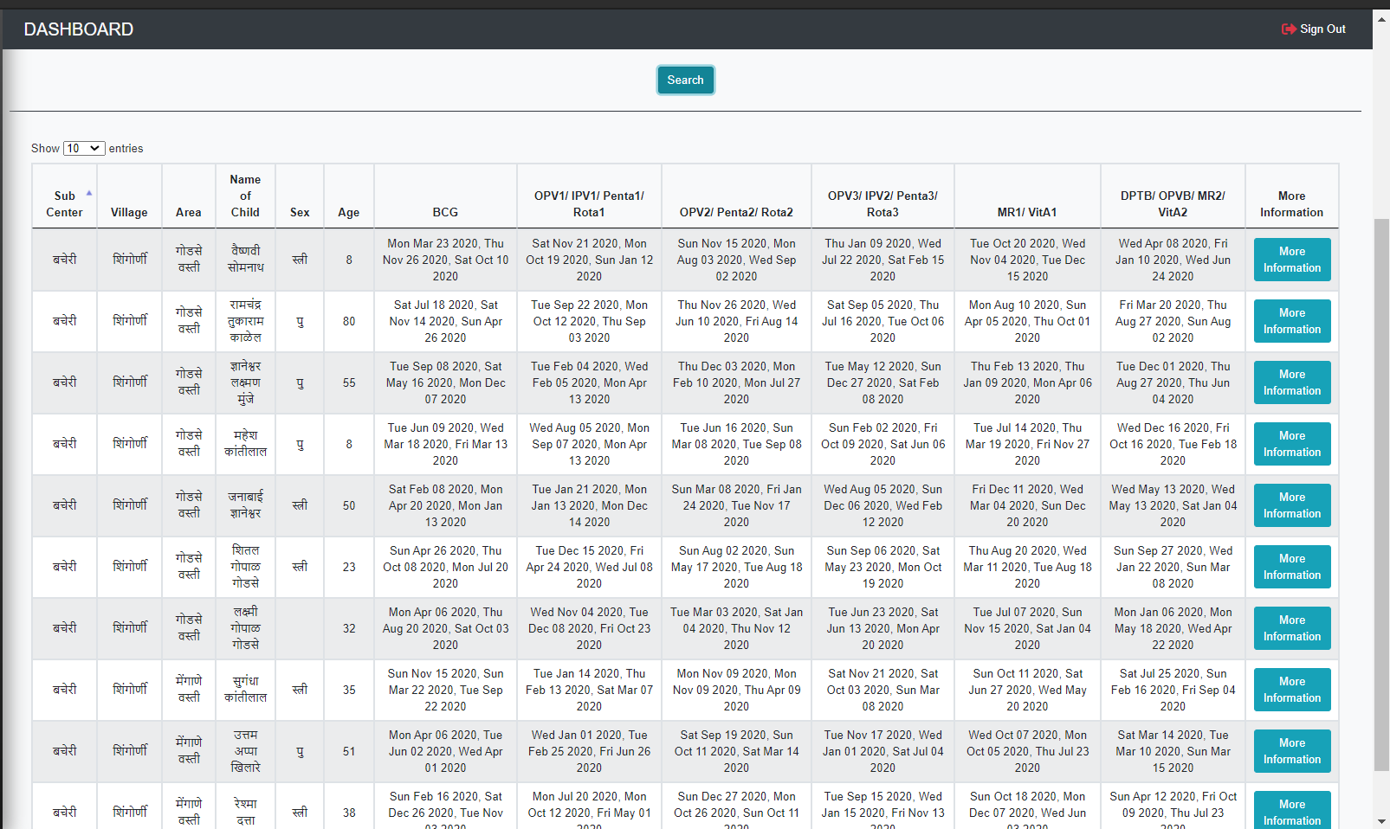

Immunization details of Infant

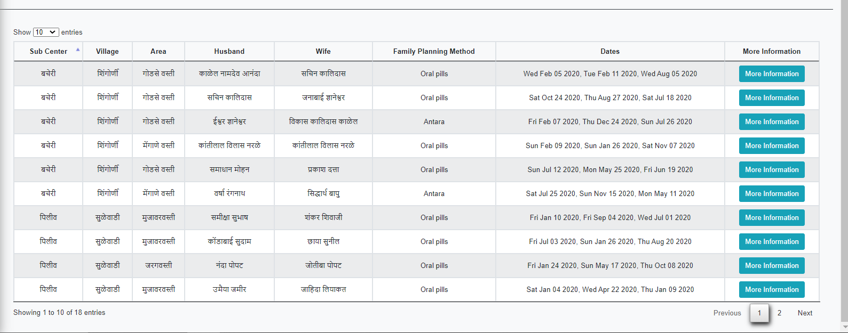

Family-Planning Method

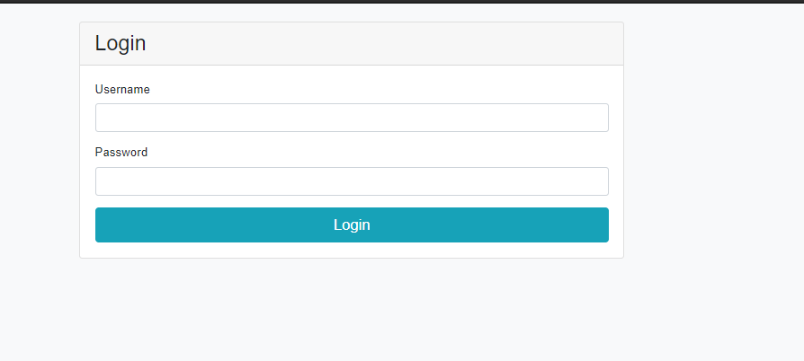

Asha Administration login